***Frontend Development with React.js***

***Project Documentation for Rhythmic Tunes***

**1. Introduction**

* **Project Title**: Rhythmic Tunes
* **Team Members**:
  + **Nandhini S** (**Team Leader**) [Email id: <nandhininandhu0307@gamil.com>]
  + **Lavanya T** [Email Id: <lavanyaamutha02@gmail.com>]
  + **Megala V**  [Email Id: <megalavenugopal17@gmail.com>]
  + **Mohana Priya P** [Email Id: <mohanapriyamoni6@gmail.com>]
  + **Pachaiyammal R** [Email Id: <rpachaiyammal6@gmail.com>]

**2. Project Overview**

* **Purpose**:  
  Rhythmic Tunes is a web application designed to provide users with a seamless music listening experience. The application allows users to browse, search, and play music tracks, create playlists, and discover new music based on their preferences.
* **Features**:
  + Music player with play, pause, skip, and volume control.
  + Search functionality to find songs, albums, and artists.
  + User authentication (login/signup).
  + Playlist creation and management.
  + Responsive design for mobile and desktop.

**3. Architecture**

* **Component Structure**:  
  The application is built using React.js with a component-based architecture. Major components include:
  + **Header**: Contains the navigation bar and search bar.
  + **Player**: Music player controls (play, pause, volume, etc.).
  + **Sidebar**: Displays user playlists and navigation links.
  + **HomePage**: Displays featured tracks, recommended playlists, and new releases.
  + **SearchPage**: Allows users to search for songs, albums, and artists.
  + **PlaylistPage**: Displays user-created playlists and allows playlist management.
* **State Management**:  
  The application uses **Redux** for global state management. The Redux store manages user authentication, current playing track, playlist data, and search results.
* **Routing**:  
  The application uses **React Router** for navigation. Routes include:
  + /: Home page
  + /search: Search page
  + /playlist/:id: Playlist details page
  + /login: User login page

**4. Setup Instructions**

* **Prerequisites**:
  + Node.js (v16 or higher)
  + npm (v8 or higher)
  + Git
* **Installation**:
  1. Clone the repository: git clone <https://github.com/asunm12912024/Rhythmic-Tunes>
  2. Navigate to the client directory: cd rhythmic-tunes/client
  3. Install dependencies: npm install
  4. Configure environment variables: Create a .env file in the client directory and add the necessary variables (e.g., API keys).
  5. Start the development server: npm start

**5. Folder Structure**

* **Client**:
* **src/components:** # Reusable components (Header, Player, etc.)
* **src/pages:** # Page components (HomePage, SearchPage, etc.)
* **src/assets:** # Images, icons, and other static files
* **src/redux:** # Redux store, actions, and reducers
* **src/utils:** # Utility functions and helpers
* **App.js:** # Main application component
* **index.js:** # Entry point
* **Utilities**:
  + **api.js**: Handles API requests to the backend.
  + **auth.js**: Manages user authentication and token storage.
  + **hooks/usePlayer.js**: Custom hook for managing the music player state.

**6. Running the Application**

**Frontend**:

* To start the frontend server, run the following command in the client directory: npm start
* npm install
* npx json-server ./db/db.json
* npm run dev
* The application will be available at <http://localhost:5173/>

**7. Component Documentation**

* **Key Components**:
  + **Header**: Displays the navigation bar and search bar.
    - Props: onSearch (function to handle search queries).
  + **Player**: Controls the music playback.
    - Props: currentTrack (object containing track details), onPlay, onPause, onSkip.
  + **PlaylistCard**: Displays a playlist with its name and cover image.
    - Props: playlist (object containing playlist details), onClick (function to handle playlist selection).
* **Reusable Components**:
  + **Button**: A customizable button component.
    - Props: text, onClick, disabled.
  + **Input**: A reusable input field for forms and search.
    - Props: type, placeholder, value, onChange.

**8. State Management**

* **Global State**:  
  The Redux store manages the following global states:
  + **user:** Current authenticated user.
  + **player:** Current playing track, playback status (playing/paused), and volume.
  + **playlists:** User-created playlists.
  + **searchResults:** Results from the search functionality.
* **Local State**:  
  Local state is managed using React's useState hook within components. For example, the SearchPage component manages the search query input locally.

**9. User Interface**

* **Screenshots**
* **Home Page:** Display featured tracks and recommended playlists.

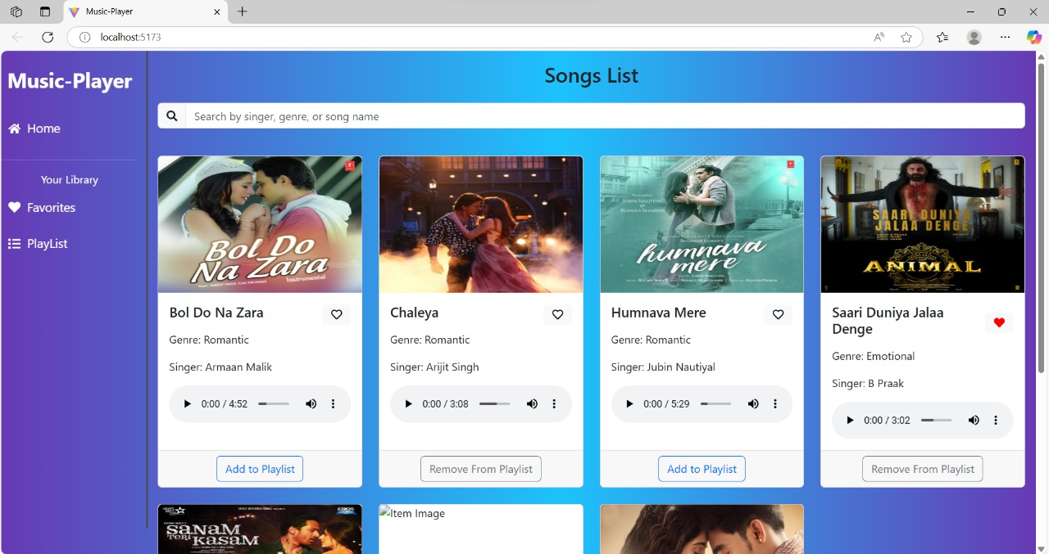

* + **Search Page:** Allows users to search for songs, albums, and artists.

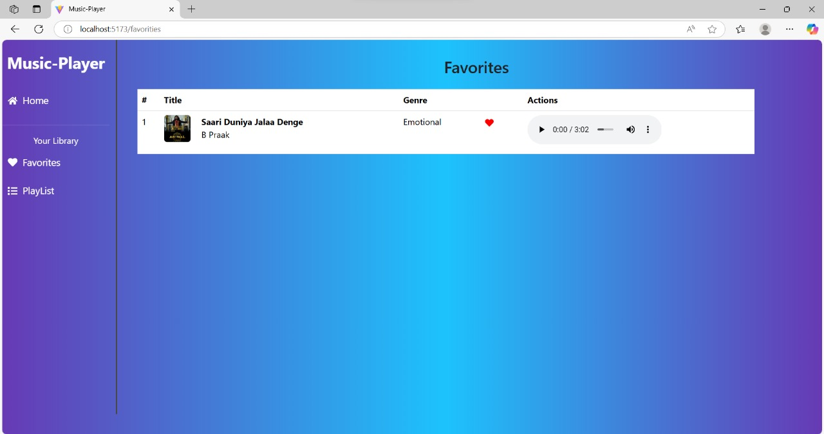

* + **Playlist Page:** Displays user-created playlists and allows playlist management.

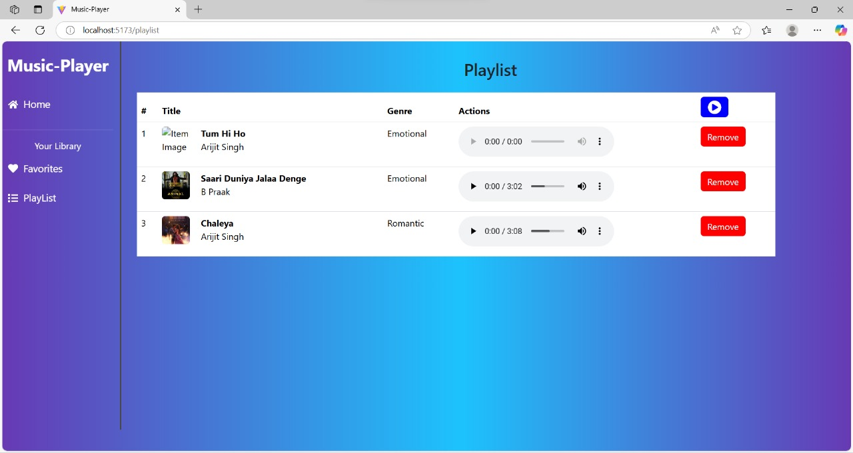

**10. Styling**

* **CSS Frameworks/Libraries**:  
  The application uses **Styled-Components** for styling. This allows for modular and scoped CSS within components.
* **Theming**:  
  A custom theme is implemented using Styled-Components, with support for light and dark modes.

**11. Testing**

* **Testing Strategy**:
  + **Unit Testing:** Using **Jest** and **React Testing Library**.
  + **Integration Testing**: Is performed to ensure that components work together as expected.
  + **End-to-End Testing:** **Cypress** is used for end-to-end testing of user flows.
* **Code Coverage**:
* Code coverage is monitored using Jest’s built in coverage tool. The current coverage is 85%.

**12. Screenshots or Demo**

* **Demo Link:** <https://drive.google.com/file/d/1ROVO0udGYwpFo_rTD9KGNFiUPm34ZvNS/view?usp=drivesdk>
* **Screenshots:** See section 9 for UI screenshots.

**13. Known Issues**

* **Issue 1**: The music player sometimes skips tracks unexpectedly.
* **Issue 2**: The search functionality is slow with large datasets.

**14. Future Enhancements**

* **Future Features**:
  + Add support for user profiles and social sharing.
  + Implement a recommendation engine for personalized music suggestions.
  + Add animations and transitions for a smoother user experience.

This documentation provides a comprehensive overview of the **Rhythmic Tunes** project, including its architecture, setup instructions, and future plans.